A000-Bulgaria-Stara Zagora-Figurine-Female-Janus-Pre and Post Parturition-Ceramic-Neolithic-5500 BCE

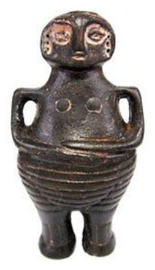 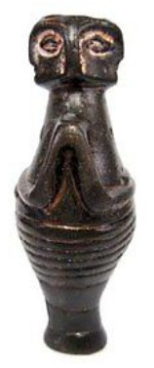 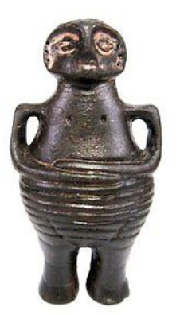 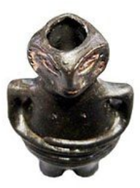

Fig. 1. A000-Bulgaria-Stara Zagora-Figurine-Female-Janus-Pre and Post Parturition-Ceramic-Neolithic-5500 BCE

Case No.: 1

**Formal Label:** A000-Bulgaria-Stara Zagora-Figurine-Female-Janus-Pre and Post Parturition-Ceramic-Neolithic-5500 BCE

**Accession Number:** A000

**Display Description:**

The original wasfound in the ruins of a Neolithic settlement in the region of Stara Zagora, Bulgaria**. This figurine** with breasts full of milk and empty and both hands on the abdomen **is intended to communicate the process of giving birth and the effects it has on the human body.**

**LC Classification:**  GN776.B9

**Date or Time Horizon:** 6th Millennium BCE

**Geographical Area:** Stara Zagora, Bulgaria

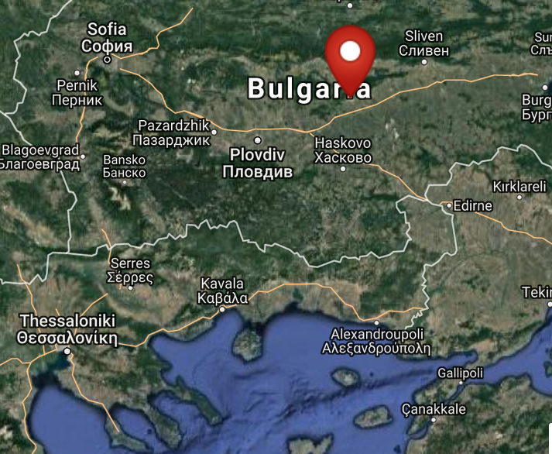

Fig. 2. Map of location of Stara Zagora, Bulgaria. From http://latitude.to/lat/42.42604/lng/25.63356

GPS coordinates: 42º25'33.74" N 25º38'0.81" E

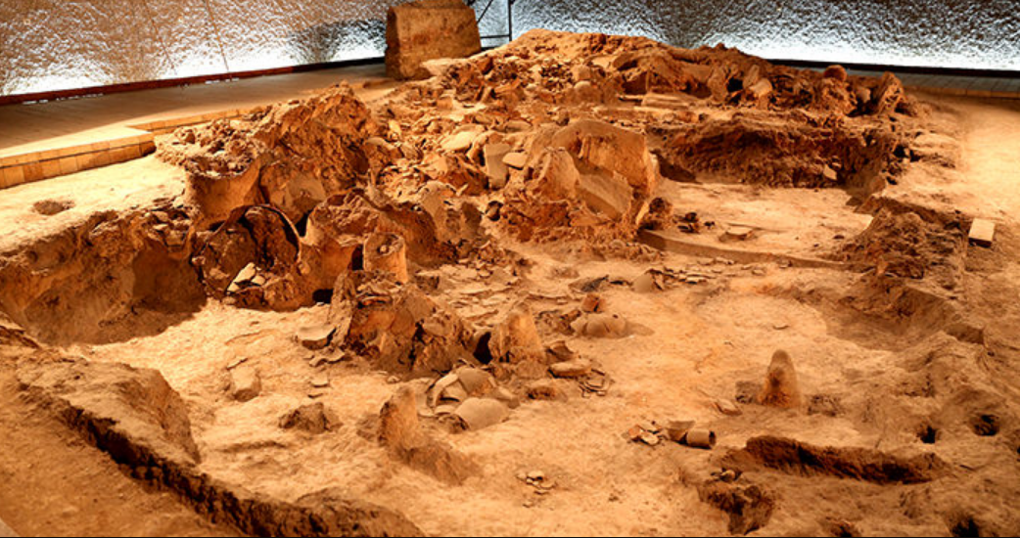

Fig. 3. Neolithic House, Stara Zagora regional Historical Museum, Bulgaria. http://www.getmetravelled.com/wp-content/uploads/2015/08/Neolithic-Dwellings-Museum_Stara_Zagora_Bulgaria.jpg

**Cultural Affiliation:** Neolithic

**Medium:** **terracotta colored with charcoal and red ochre, Fe2O3.**

**Dimensions:** **71/37 mm**

**Weight: 25 g;**

**Provenance:** Stara Zagora regional Historical Museum

**Condition:** museum replica

**Discussion:** These figurines from Stara Zagora date to the beginning of farming in central Europe and their red ochre geometric markings probably emulated the shape of tattoos or body paint.

**References:**

Gaul, James Harvey. [1948. *The neolithic period in Bulgaria : early food-producing cultures of Eastern Europe*](http://www.worldcat.org/title/neolithic-period-in-bulgaria-early-food-producing-cultures-of-eastern-europe/oclc/1001170812&referer=brief_results)*.*  Cambridge (Mass.): Peabody Museum.

[Krauß](http://www.worldcat.org/search?q=au%3AKrau%C3%9F%2C+Raiko.&qt=hot_author), Raiko; [Nedko Elenski](http://www.worldcat.org/search?q=au%3AElenski%2C+Nedko.&qt=hot_author" \o "Search for more by this author); [Bernhard Weninger](http://www.worldcat.org/search?q=au%3AWeninger%2C+Bernhard.&qt=hot_author); [Lee Clare](http://www.worldcat.org/search?q=au%3AClare%2C+Lee.&qt=hot_author); [Canan Çakirlar](http://www.worldcat.org/search?q=au%3AC%CC%A7akirlar%2C+Canan.&qt=hot_author" \o "Search for more by this author); [Petǎr Zidarov](http://www.worldcat.org/search?q=au%3AZidarov%2C+Peta%CC%8Cr.&qt=hot_author" \o "Search for more by this author). 2014. “Beginnings of the Neolithic in Southeast Europe : the early Neolithic sequence and absolute dates from Džuljunica-Smǎrdeš (Bulgaria),” *Documenta Praehistorica. Poročilo o raziskovanju paleolitika, neolitika in eneolitika v Sloveniji. Neolitske študije = Neolithic studies*, 41:51-77.

Todorova, Khenrieta. 1978. *The eneolithic period in Bulgaria in the fifth millennium B.C*. Oxford: British Archaeological Reports.